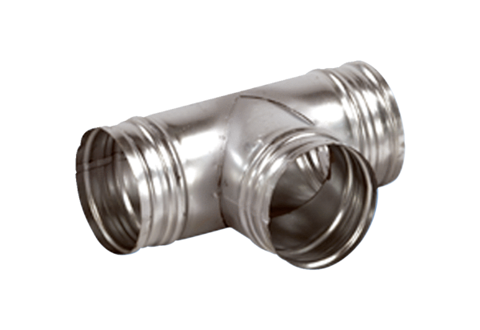90° branch AB 180-100Packing unit: 1 pieceRange: K
Article number: 0055.0375Manufacturer: MAICO

