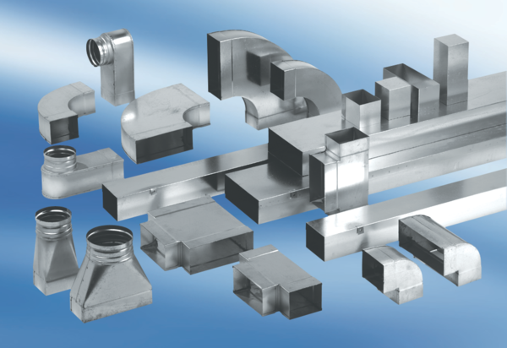Intermediate piece, symmetric USSN80/150/100Packing unit: 1 pieceRange: K
Article number: 0055.0685Manufacturer: MAICO

