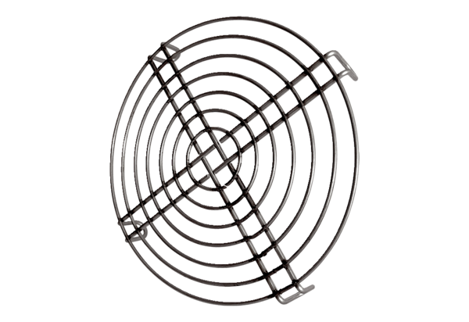Inlet protective grille SGEI K 35Packing unit: 1 pieceRange: C
Article number: 0073.0466Manufacturer: MAICO

