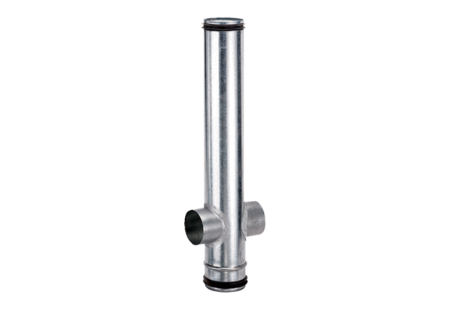Fire protection compensation element BA 160/80-2Packing unit: 1 pieceRange: B
Article number: 0093.1006Manufacturer: MAICO

