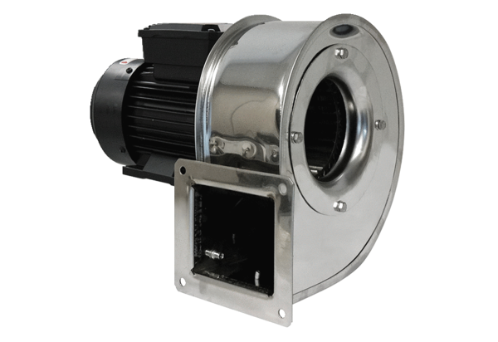Centrifugal blower GRM ES 18/2 DPacking unit: 1 pieceRange: C
Article number: 0073.0324Manufacturer: MAICO

