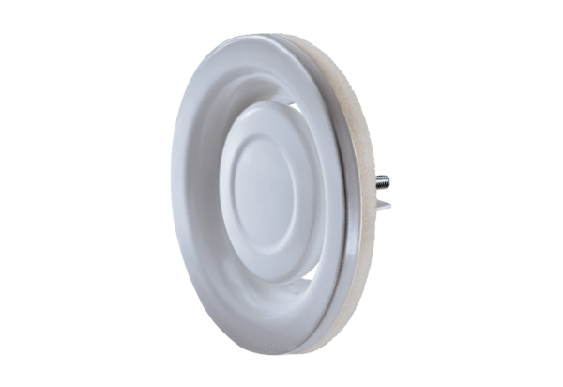Disk valve, metal TFA 20Packing unit: 1 pieceRange: C
Article number: 0151.0373Manufacturer: MAICO

