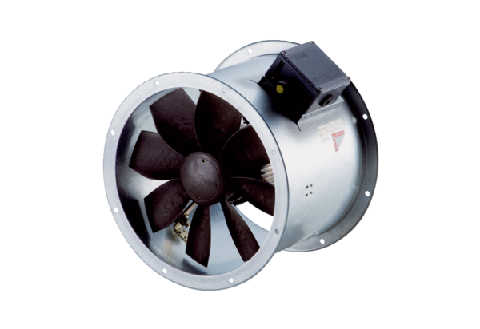Axial duct fan DZR 30/4 B Ex ePacking unit: 1 pieceRange: C
Article number: 0086.0704Manufacturer: MAICO

