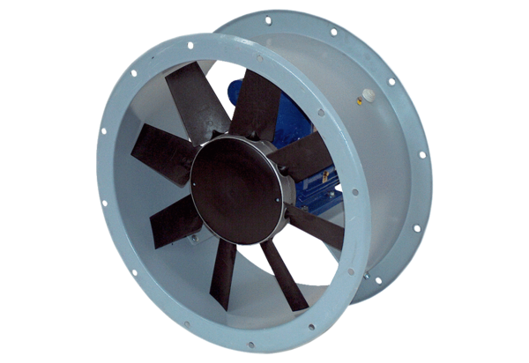Axial duct fan DAR 80/8-2 ExPacking unit: 1 pieceRange: C
Article number: 0073.0361Manufacturer: MAICO

