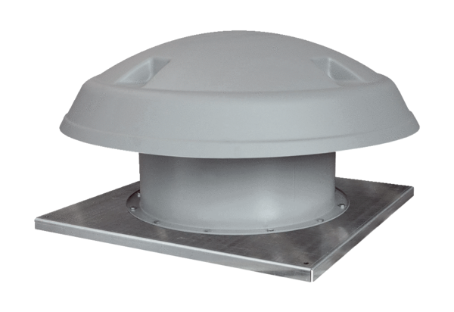Axial roof fan DAD 90/4Packing unit: 1 pieceRange: C
Article number: 0073.0077Manufacturer: MAICO

