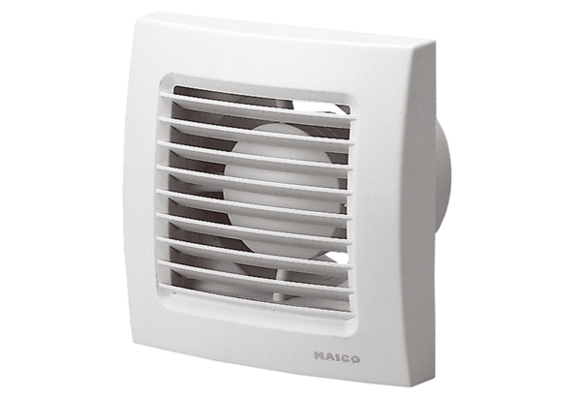Small room fan ECA 150 VZPacking unit: 1 pieceRange: A
Article number: 0084.0013Manufacturer: MAICO

