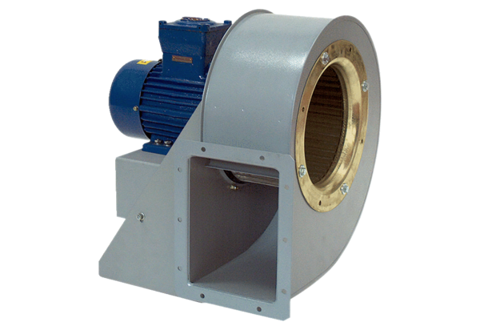Centrifugal blower GRM HD 22/4 ExPacking unit: 1 pieceRange: C
Article number: 0073.0399Manufacturer: MAICO

