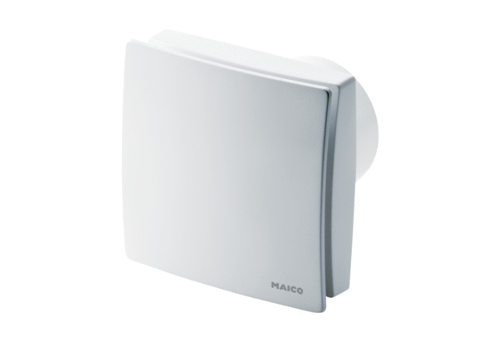Small room fan ECA 150 ipro RCHPacking unit: 1 pieceRange: A
Article number: 0084.0088Manufacturer: MAICO

