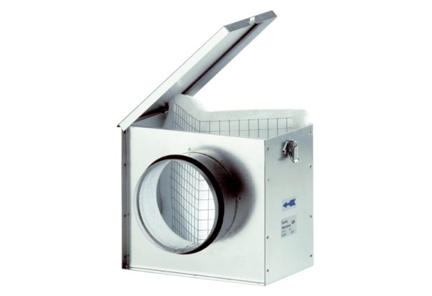Air filter TFE 20Packing unit: 1 pieceRange: C
Article number: 0149.0043Manufacturer: MAICO

