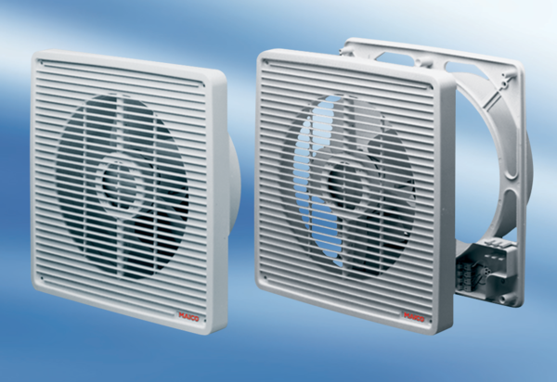Wall-mounted fan ET 31Packing unit: 1 pieceRange: C
Article number: 0081.0503Manufacturer: MAICO

