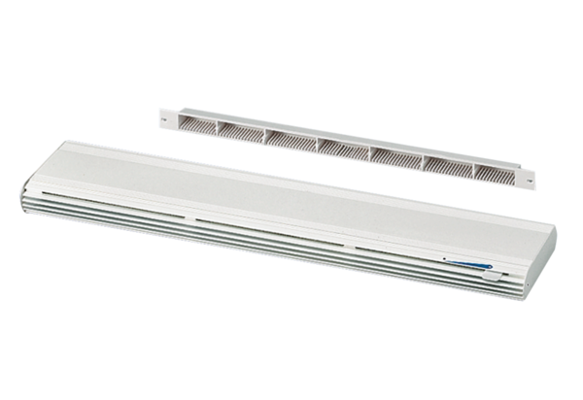Outside air opening ZE 45 F whitePacking unit: 1 pieceRange: K
Article number: 0152.0044Manufacturer: MAICO

