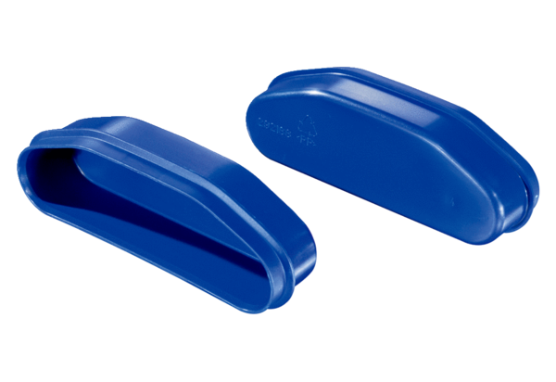Blind cover FFS-DPacking unit: 5 piecesRange: K
Article number: 0055.0881Manufacturer: MAICO

