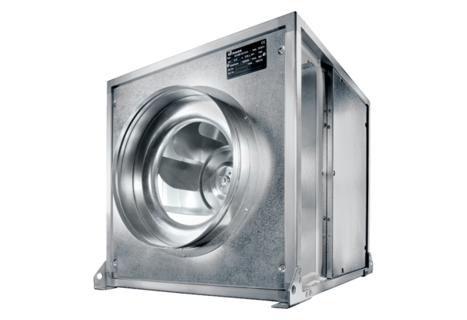Quickbox DSQ 45/6 KPacking unit: 1 pieceRange: C
Article number: 0080.0079Manufacturer: MAICO

