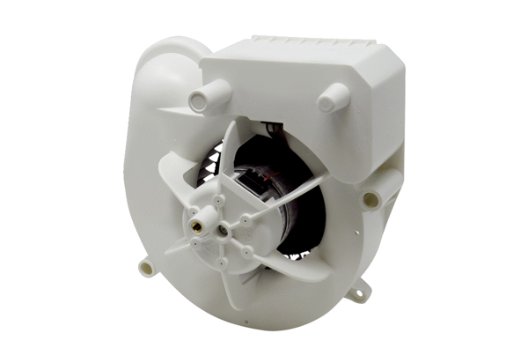Fan insert VE ER-AP 60 VZRange: B
Article number: E084.0151.0000Manufacturer: MAICO

