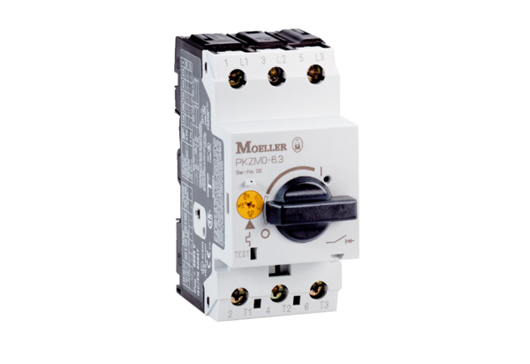Motor protection switch MVEx 1,6Packing unit: 1 pieceRange: D
Article number: 0157.0549Manufacturer: MAICO

