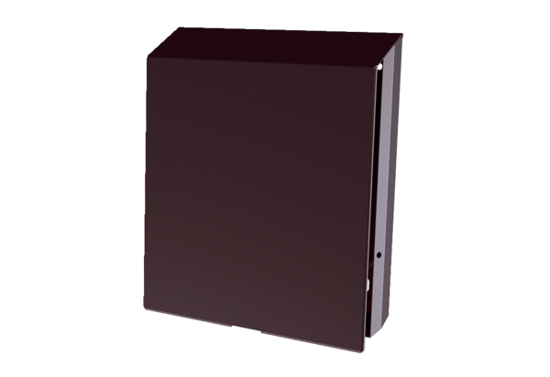External cover PP 45 ASPacking unit: 1 pieceRange: K
Article number: 0093.0612Manufacturer: MAICO

