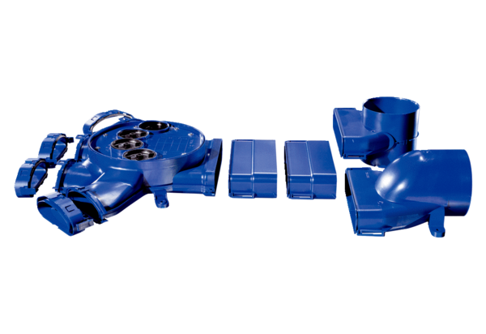Distributor FFS-V4Packing unit: 1 pieceRange: K
Article number: 0055.0871Manufacturer: MAICO

