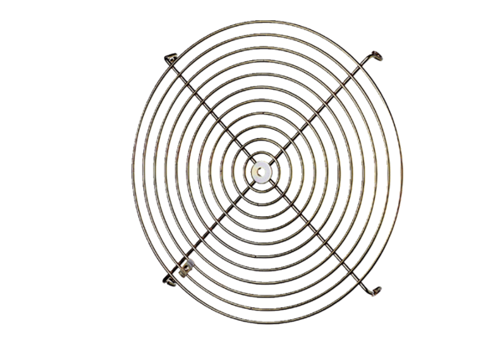Protective grille SGM 18 ExPacking unit: 1 pieceRange: C
Article number: 0150.0131Manufacturer: MAICO

