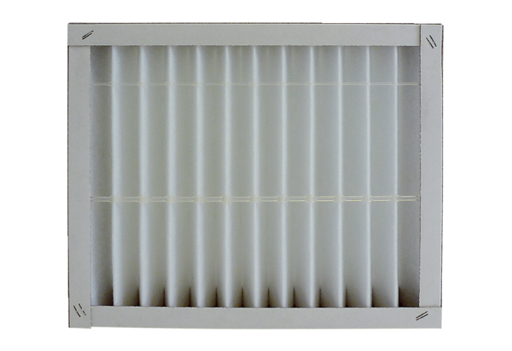Air filter, replacement ECR 25-31 G4Packing unit: 1 pieceRange: C
Article number: 0093.0894Manufacturer: MAICO

