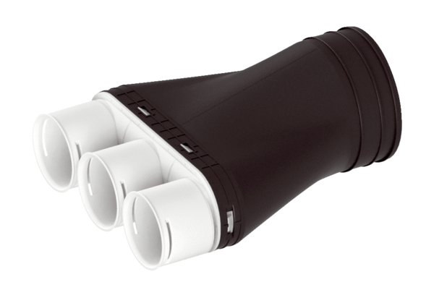Adapter MA-AD3-63Packing unit: 1 pieceRange: K
Article number: 0059.2120Manufacturer: MAICO

