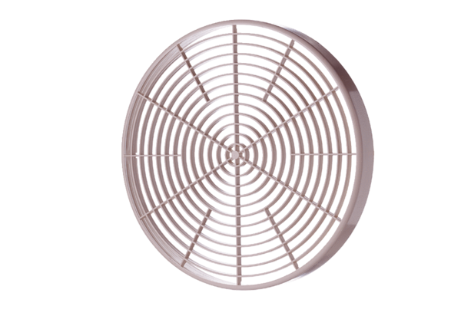Protective grille SGM 18Packing unit: 1 pieceRange: C
Article number: 0059.0626Manufacturer: MAICO

