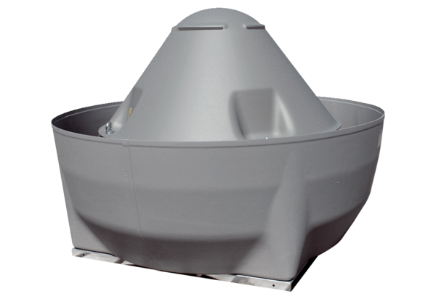Centrifugal roof fan DRD V 35/4 ExPacking unit: 1 pieceRange: C
Article number: 0073.0546Manufacturer: MAICO

