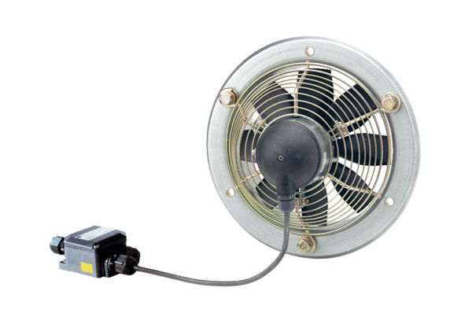Axial wall fan EZS 20/4 E Ex ePacking unit: 1 pieceRange: C
Article number: 0094.0200Manufacturer: MAICO

