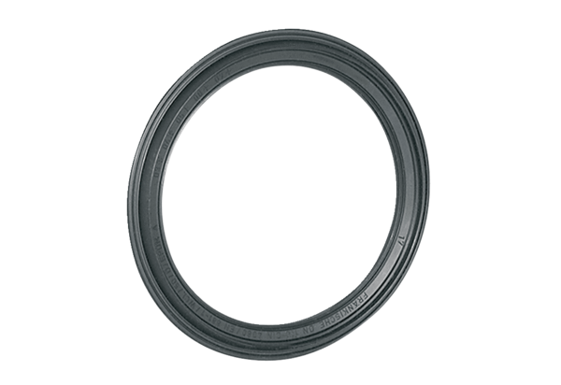Sealing ring MF-FDR63Packing unit: 10 piecesRange: K
Article number: 0175.0261Manufacturer: MAICO

