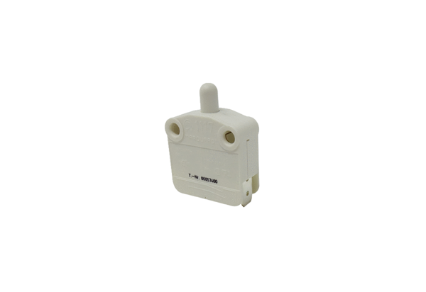Door contact switch TS 1Range: K
Article number: E157.1150.0000Manufacturer: MAICO

