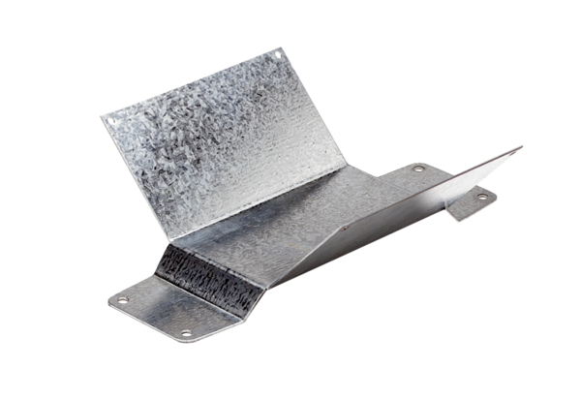Mounting foot FUM 15/18Packing unit: 1 pieceRange: C
Article number: 0036.0001Manufacturer: MAICO

