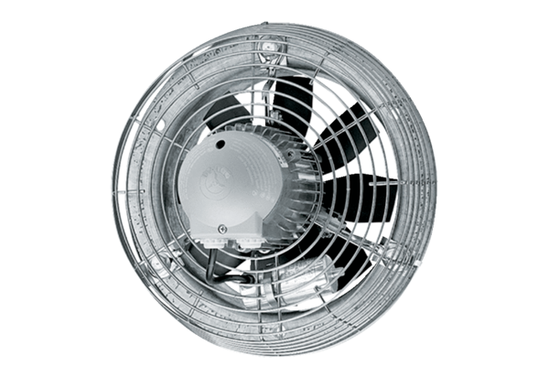Axial wall fan DZS 35/6 BPacking unit: 1 pieceRange: C
Article number: 0094.0017Manufacturer: MAICO

