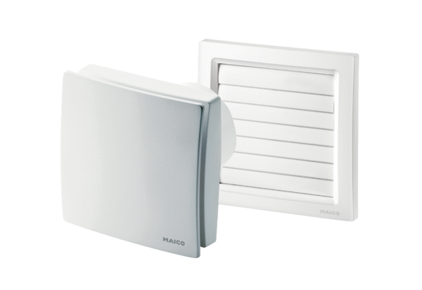Small room fan AKE 150Packing unit: 1 pieceRange: A
Article number: 0084.0099Manufacturer: MAICO

