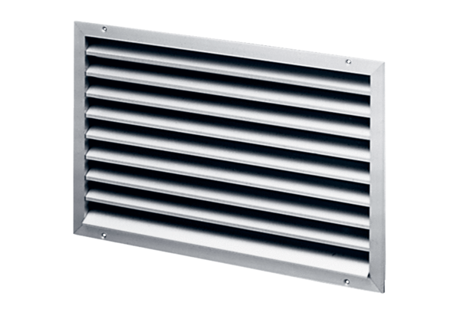External grille LAP 22Packing unit: 1 pieceRange: D
Article number: 0151.0250Manufacturer: MAICO

