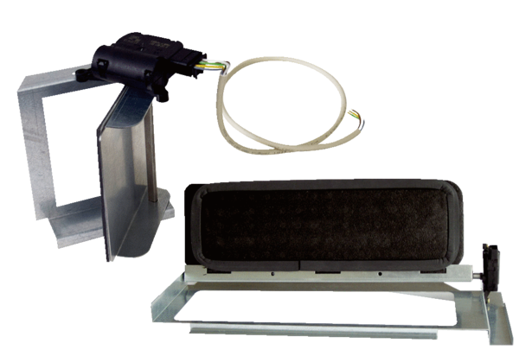Bypass for heat exchanger SK 300 WTPacking unit: 1 pieceRange: D
Article number: 0152.0051Manufacturer: MAICO

