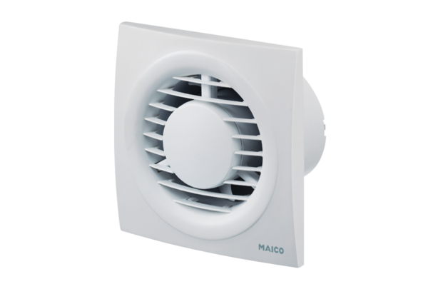Small room fan ECA piano StandardPacking unit: 1 pieceRange: A
Article number: 0084.0080Manufacturer: MAICO

