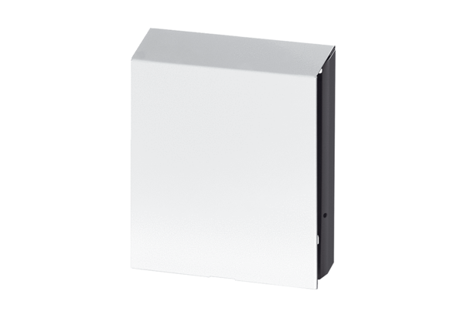External cover PP 45 AWPacking unit: 1 pieceRange: K
Article number: 0093.0178Manufacturer: MAICO

