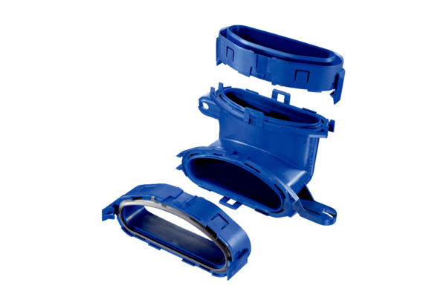Vertical flat duct elbow FFS-BVPacking unit: 1 pieceRange: K
Article number: 0055.0877Manufacturer: MAICO

