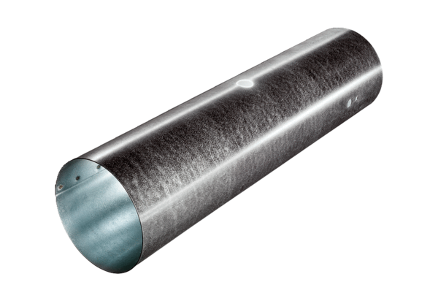Duct piece for servomotor MSR 100Packing unit: 1 pieceRange: C
Article number: 0092.0510Manufacturer: MAICO

