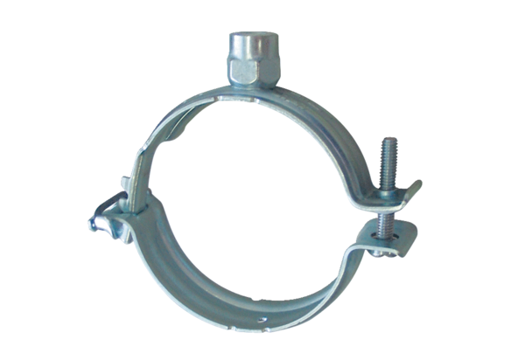Mounting clamp MF-S75Packing unit: 1 pieceRange: K
Article number: 0018.0470Manufacturer: MAICO

