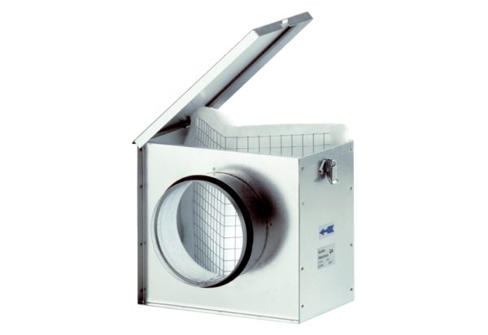Air filter TFE 15Packing unit: 1 pieceRange: C
Article number: 0149.0048Manufacturer: MAICO

