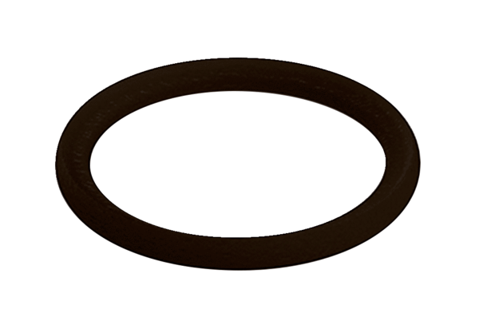Sealing ring MA-D90Packing unit: 10 piecesRange: K
Article number: 0175.0335Manufacturer: MAICO

