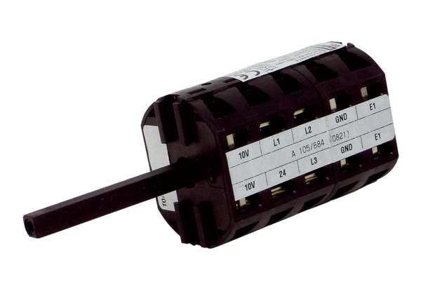Repair switch RS MDR40/45Packing unit: 1 pieceRange: E
Article number: E157.1635.0000Manufacturer: MAICO

