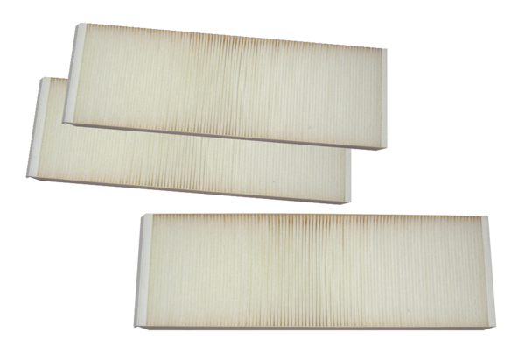Air filter, replacement WSFG 320/470Packing unit: 1 set (3 pieces)Range: K
Article number: 0092.0588Manufacturer: MAICO

