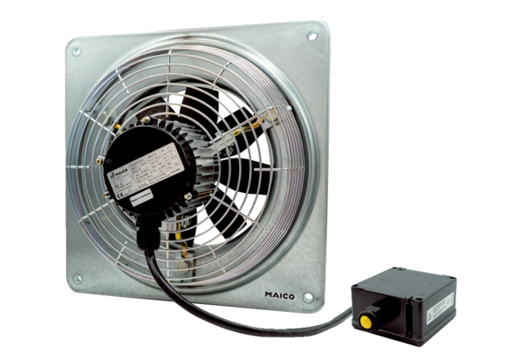Axial wall fan DZQ 35/2 B Ex ePacking unit: 1 pieceRange: C
Article number: 0083.0179Manufacturer: MAICO

