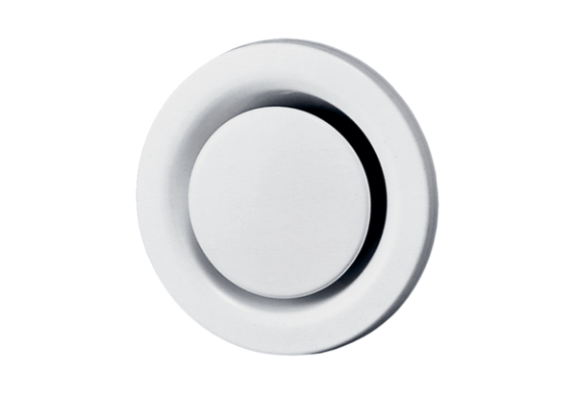Disk valve, metal TM 12Packing unit: 1 pieceRange: C
Article number: 0151.0196Manufacturer: MAICO

