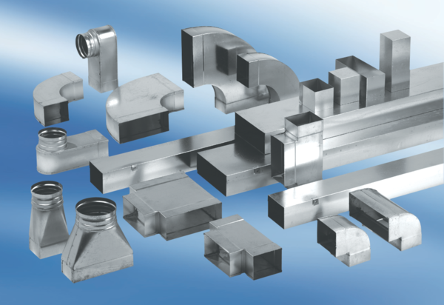45° channel elbows, vertical KB45V/70/170Packing unit: 1 pieceRange: K
Article number: 0055.0602Manufacturer: MAICO

