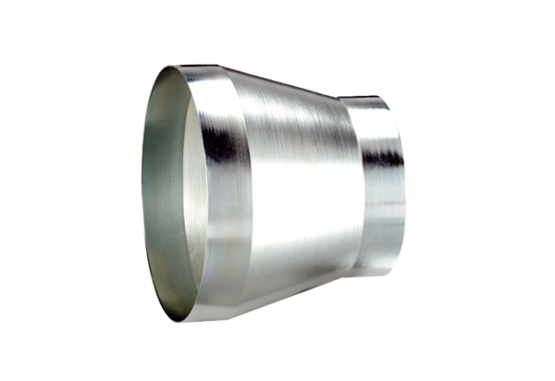Reducer REM 18/14 ExPacking unit: 1 pieceRange: C
Article number: 0055.0304Manufacturer: MAICO

