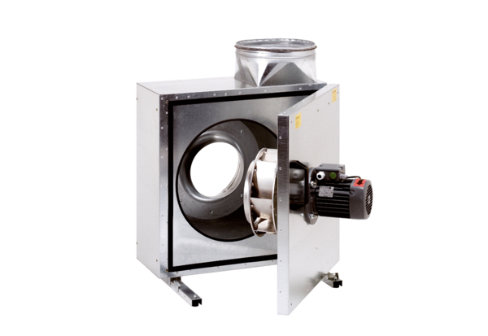Sound-insulated ventilation box EKR 35Packing unit: 1 pieceRange: C
Article number: 0080.0922Manufacturer: MAICO

