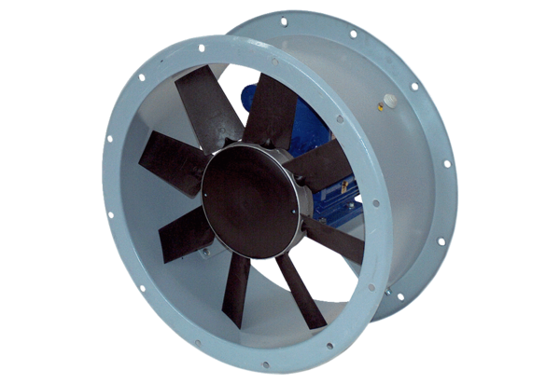Axial duct fan DAR 125/8 4Packing unit: 1 pieceRange: C
Article number: 0073.0191Manufacturer: MAICO

