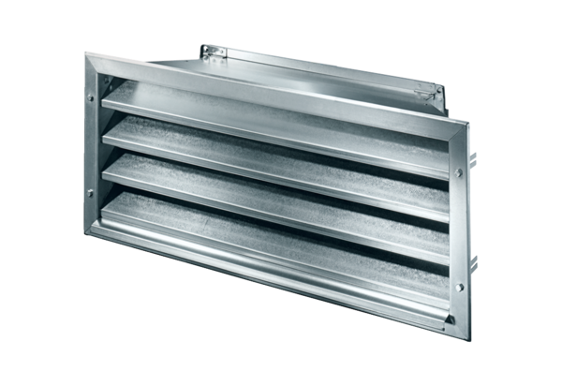External grille LZP-R 28Packing unit: 1 pieceRange: D
Article number: 0151.0383Manufacturer: MAICO

